Results - Modelling Financial Time series data

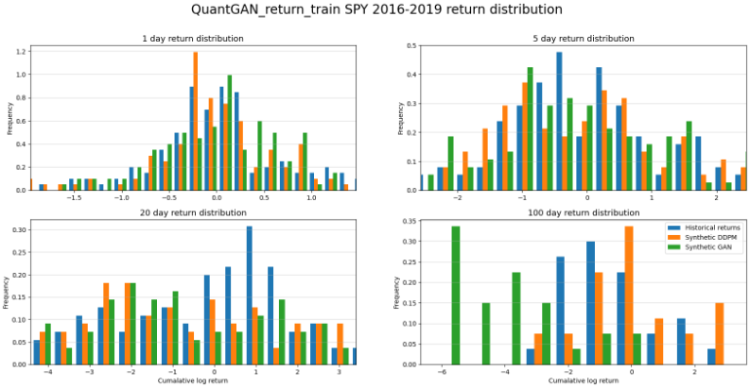

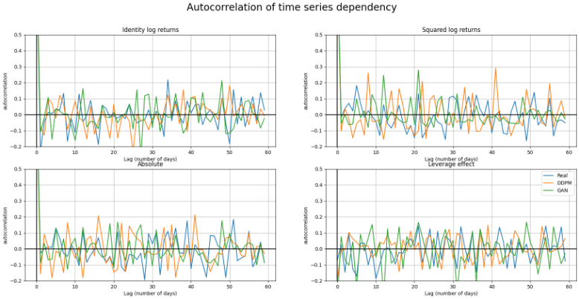

Stock Metrics

|  | QuantGan | TabDDPM |
| --- | --- | --- |
| EMD(1) ↓ | 8.033986e-04 | **4.403211e-04** |
| EMD(5) ↓ | 2.058422e-03 | **1.818781e-03** |
| EMD(20) ↓ | 1.072807e-02 | **8.936049e-03** |
| EMD(100) ↓ | 1.269983e-01 | **2.054403e-02** |
| K-S Test  (p-value) ↑ | 42.455190% | **96.380698%** |
| ACF(ᆞ) ↓ | 1.211521e-01 | **1.056656e-01** |
| ACF(|ᆞ|) ↓ | **1.115744e-01** | 1.326045e-01 |
| ACF((ᆞ)2) ↓ | **1.027946e-01** | 1.374898e-01 |
| Leverage Effect ↓ | 1.310409e-01 | **1.083866e-01** |
| ACF Score ↓ | **2.342331e-01** | 2.437218e-01 |

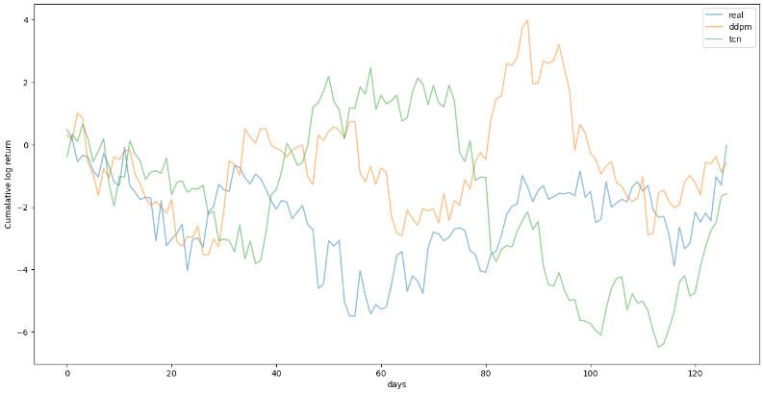

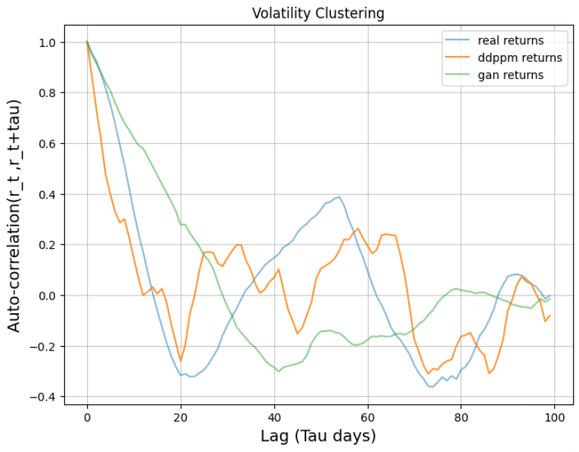

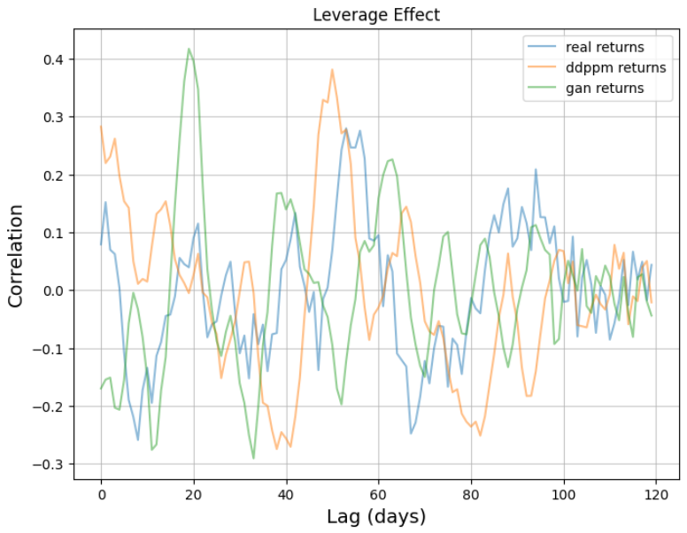

—-------------x—----------------x—--------------

* 1. **Modified TabDDPM for structured data of options:**

The notion that each row of the data represents an i.i.d datapoint has always been an assumption that statisticians would like to mitigate. Options data is unique because some known information of a row can be injected in another row. A call option with strike A should always be sold at a discount to a call option with strike B when strike A > strike B otherwise an arbitrage situation arises. SImilarly, on the other side of the coin, a put option with higher strike is the costlier contract. The reconstruction phase of variational encoder given forth by Dogariu et al.[16] inspired the injection of previous strike’s information in the modelling process.

If xi represents an option with a bigger strike than xi-1, then I propose the modified forward diffusion process such that q(xT) is a normal distribution with a mean that is the difference between xi and xi-1. Thus, every price of subsequent strikes will be modelled from a translated normal distribution relative to the previous strike. So, (6) becomes -

$q(x_{iT}) :=N(x_{iT};(P(x_{i})-P(x_{i-1}),I)$ (15)

where $x_{i}$ is the price feature of x and P(xi) represents the price of the bigger strike whereas P(xi-1) represents the price of the smaller strike.

<https://www.mdpi.com/1911-8074/15/10/461> - On Financial Distributions Modelling Methods: Application on Regression Models for Time Series

<https://books.google.com/books?hl=en&lr=&id=KQ5pDQAAQBAJ&oi=fnd&pg=PR7&dq=modelling+financial+time+series+distribution&ots=ndUJWiqyLO&sig=GhrEyeflWmZsDWw9-drZEwI4p0o#v=onepage&q=modelling%20financial%20time%20series%20distribution&f=false> - Modelling Financial Time Series (2nd Edition)

<https://link.springer.com/chapter/10.1007/978-88-470-0502-0_19> - Modelling Finanacial Time Series